UNITED STATES
SECURITIES AND EXCHANGE COMMISSION
Washington, D.C. 20549
FORM 8-K
CURRENT REPORT
PURSUANT TO SECTION 13 OR 15(d) OF THE SECURITIES EXCHANGE ACT OF 1934
Date of Report (Date of earliest event reported): July 13, 2026
__________________________________________

First Busey Corporation
(Exact name of Registrant as specified in its charter)
__________________________________________
Nevada |  |  | 0-15950 |  |  | 37-1078406
(State of Incorporation) |  |  | (Commission File Number) |  |  | (I.R.S. Employer Identification No.)
11440 Tomahawk Creek Parkway
Leawood, Kansas 66211
(Address of Principal Executive Offices)
 |  |  | (217) 365-4544
(Registrant’s telephone number, including area code)
N/A
(Former name or former address, if changed since last report.)
Check the appropriate box below if the Form 8-K filing is intended to simultaneously satisfy the filing obligation of the registrant under any of the following provisions:
☐ |  |  | Written communications pursuant to Rule 425 under the Securities Act (17 CFR 230.425)
☐ |  |  | Soliciting material pursuant to Rule 14a-12 under the Exchange Act (17 CFR 240.14a-12)
☐ |  |  | Pre-commencement communications pursuant to Rule 14d-2(b) under the Exchange Act (17 CFR 240.14d-2(b))
☐ |  |  | Pre-commencement communications pursuant to Rule 13e-4(c) under the Exchange Act (17 CFR 240.13e-4(c))
Securities registered pursuant to Section 12(b) of the Act:
Title of each class |  |  |  |  |  | Trading Symbol(s) |  |  |  |  |  | Name of each exchange on which registered
Common Stock, $0.001 par value |  |  |  |  |  | BUSE |  |  |  |  |  | The Nasdaq Stock Market LLC
Depositary Shares, each representing a 1/40th interest in a share of 8.25% Fixed-Rate Series B Non-Cumulative Perpetual Preferred Stock, $0.001 par value |  |  |  |  |  | BUSEP |  |  |  |  |  | The Nasdaq Stock Market LLC
Indicate by check mark whether the Registrant is an emerging growth company as defined in Rule 405 of the Securities Act of 1933 (§230.405 of this chapter) or Rule 12b-2 of the Securities Exchange Act of 1934 (§240.12b-2 of this chapter). ☐
If an emerging growth company, indicate by check mark if the Registrant has elected not to use the extended transition period for complying with any new or revised financial accounting standards provided pursuant to Section 13(a) of the Exchange Act. ☐

Item 5.02. Departure of Directors or Certain Officers; Election of Directors; Appointment of Certain Officers; Compensatory Arrangements of Certain Officers.
Letter Agreement with Van A. Dukeman
On July 13, 2026, First Busey Corporation (“First Busey”) entered into a letter agreement (the “Letter Agreement”) with Van A. Dukeman, the Chairman, President and Chief Executive Officer of First Busey, and Chairman and Chief Executive Officer of Busey Bank (the “Bank”). The Letter Agreement represents the extension of Mr. Dukeman’s current term serving as Chief Executive Officer of First Busey and Chief Executive Officer of the Bank for approximately three years through July 1, 2029 (the “Expected Term”), which First Busey’s Board of Directors has deemed to be in the best interests of First Busey at this time.
Mr. Dukeman’s base salary, annual bonus and long-term equity incentive opportunities remain unchanged. The Letter Agreement provides that First Busey will review Mr. Dukeman’s base salary, annual bonus and long-term equity incentive opportunities from time to time based on personal performance, company performance and market conditions. As long as Mr. Dukeman remains employed during the Expected Term, he will continue to be eligible for an annual bonus for each year he is employed, prorated for any partial years, and be eligible for an annual long-term equity incentive award in 2027 and 2028 (but not 2029).
Pursuant to the Letter Agreement, in consideration for Mr. Dukeman’s agreement to extend his current term and to forgo his annual long-term equity incentive award in 2029, First Busey will grant him a one-time retention award in the form of restricted stock units (the “Retention RSUs”) with an aggregate grant date value of $2,067,749.88, which will vest on July 1, 2029, subject to his continued employment through such date. In the event that, prior to the end of the Expected Term, Mr. Dukeman experiences a qualifying termination, as defined below or pursuant to the First Busey Corporation Second Amended 2020 Equity Incentive Plan, or Mr. Dukeman’s employment terminates due to his death or disability, the Retention RSUs will vest.
Pursuant to the Letter Agreement, in the event that (a) Mr. Dukeman’s employment is terminated without cause or (b) Mr. Dukeman resigns in accordance with his constructive discharge rights (each such termination, a “qualifying termination”), Mr. Dukeman will be entitled to (i) any annual bonus or long-term incentive award earned or accrued but not yet paid, (ii) an amount equal to the sum of (x) his then applicable base salary through the remainder of the Expected Term and (y) annual performance bonuses (based on his then most recent annual performance bonus) that would have been paid during the remainder of the Expected Term, (iii) payment for the value of the contributions that would have been made to Mr. Dukeman under all applicable retirement and other employee benefit plans had his employment continued through December 31 of the year in which such termination of employment occurs and (iv) continuing coverage under all existing life, health and disability programs for one year following his termination date.
The Letter Agreement also requires that Mr. Dukeman continue to hold no less than 300,000 shares of First Busey’s common stock through the second anniversary of his termination of employment.
Except as provided therein, the Letter Agreement does not amend or change Mr. Dukeman’s existing employment agreement, which was previously amended pursuant to the letter agreement between Mr. Dukeman and First Busey dated as of August 26, 2024 (the “Prior Letter Agreement”). Accordingly, the current vesting treatment of Mr. Dukeman’s equity awards other than the Retention RSUs will continue to apply, and Mr. Dukeman remains subject to the non-competition covenant set forth in the Prior Letter Agreement.
The foregoing description of the Letter Agreement does not purport to be complete and is qualified in its entirety by reference to the full text of the Letter Agreement, which is attached hereto as Exhibit 10.1 and is incorporated herein by reference.
In connection with the execution of the Letter Agreement, First Busey issued a press release. A copy of the press release is attached hereto as Exhibit 99.1.
The information in Exhibit 99.1 attached hereto is being “furnished” and will not, except to the extent required by applicable law or regulation, be deemed “filed” by First Busey for purposes of Section 18 of the Securities Exchange Act of 1934, as amended (the “Exchange Act”), or otherwise subject to the liabilities of that section, nor will any of such information or exhibits be deemed incorporated by reference into any filing under the Securities Act of 1933, as amended, or the Exchange Act.

Item 8.01 Other Events.
On July 14, 2026, First Busey declared a quarterly cash dividend of $0.26 per share on its outstanding shares of common stock. The dividend is payable on July 31, 2026, to stockholders of record as of July 24, 2026.

Item 9.01. Financial Statements and Exhibits.
Exhibit Number |  |  |  |  |  | Description of Exhibit
10.1 |  |  |  |  |  | Letter Agreement, dated July 13, 2026, by and among First Busey Corporation, Busey Bank and Van A. Dukeman.*
99.1 |  |  |  |  |  | Press Release, dated July 14, 2026.
104 |  |  |  |  |  | Cover Page Interactive Data File (embedded within the Inline XBRL document and included in Exhibit 101)
___________________________________________
*Filed herewith

Signature
Pursuant to the requirements of the Securities Exchange Act of 1934, the Registrant has duly caused this report to be signed on its behalf by the undersigned, thereunto duly authorized.
 |  |  |  |  |  |  |  |  |  |  |  | FIRST BUSEY CORPORATION
Date: |  |  | July 14, 2026 |  |  |  |  |  | By: |  |  | /s/ CHRISTOPHER H.M. CHAN
 |  |  |  |  |  |  |  |  |  |  |  | Christopher H.M. Chan
 |  |  |  |  |  |  |  |  |  |  |  | Chief Financial Officer
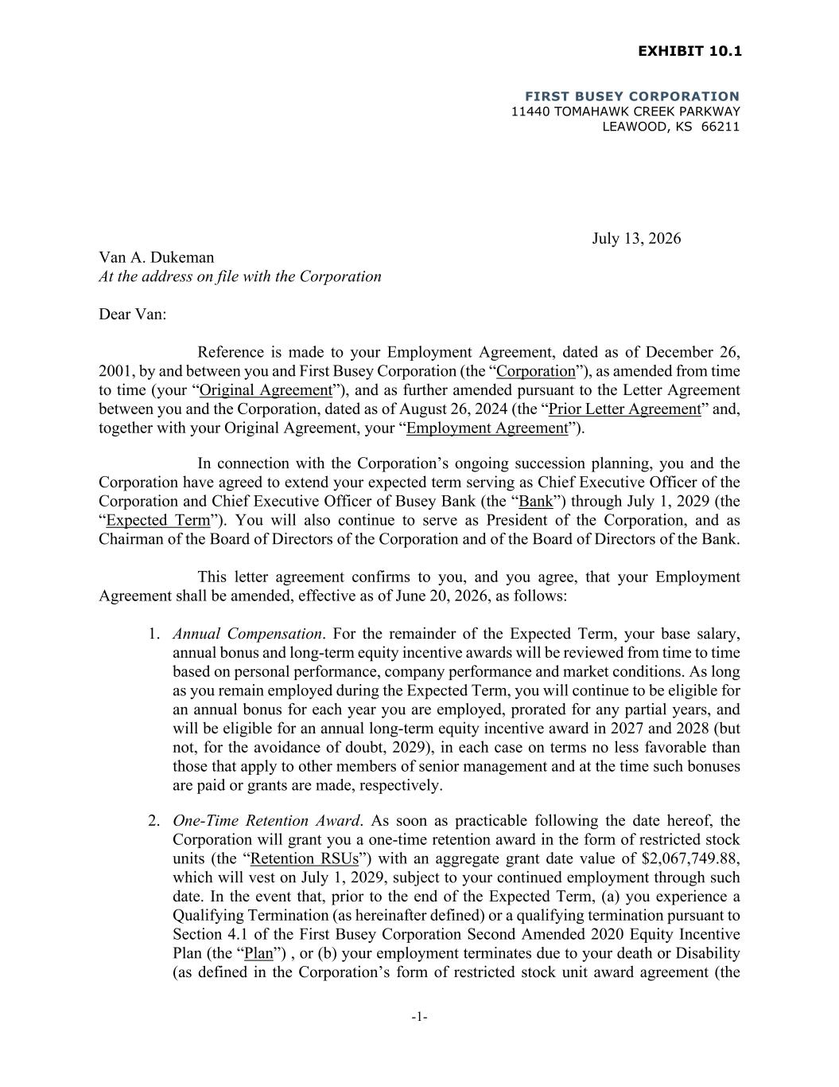

FIRST BUSEY CORPORATION 11440 TOMAHAWK CREEK PARKWAY LEAWOOD, KS 66211 -1- July 13, 2026 Van A. Dukeman At the address on file with the Corporation Dear Van: Reference is made to your Employment Agreement, dated as of December 26, 2001, by and between you and First Busey Corporation (the “Corporation”), as amended from time to time (your “Original Agreement”), and as further amended pursuant to the Letter Agreement between you and the Corporation, dated as of August 26, 2024 (the “Prior Letter Agreement” and, together with your Original Agreement, your “Employment Agreement”). In connection with the Corporation’s ongoing succession planning, you and the Corporation have agreed to extend your expected term serving as Chief Executive Officer of the Corporation and Chief Executive Officer of Busey Bank (the “Bank”) through July 1, 2029 (the “Expected Term”). You will also continue to serve as President of the Corporation, and as Chairman of the Board of Directors of the Corporation and of the Board of Directors of the Bank. This letter agreement confirms to you, and you agree, that your Employment Agreement shall be amended, effective as of June 20, 2026, as follows: 1. Annual Compensation. For the remainder of the Expected Term, your base salary, annual bonus and long-term equity incentive awards will be reviewed from time to time based on personal performance, company performance and market conditions. As long as you remain employed during the Expected Term, you will continue to be eligible for an annual bonus for each year you are employed, prorated for any partial years, and will be eligible for an annual long-term equity incentive award in 2027 and 2028 (but not, for the avoidance of doubt, 2029), in each case on terms no less favorable than those that apply to other members of senior management and at the time such bonuses are paid or grants are made, respectively. 2. One-Time Retention Award. As soon as practicable following the date hereof, the Corporation will grant you a one-time retention award in the form of restricted stock units (the “Retention RSUs”) with an aggregate grant date value of $2,067,749.88, which will vest on July 1, 2029, subject to your continued employment through such date. In the event that, prior to the end of the Expected Term, (a) you experience a Qualifying Termination (as hereinafter defined) or a qualifying termination pursuant to Section 4.1 of the First Busey Corporation Second Amended 2020 Equity Incentive Plan (the “Plan”) , or (b) your employment terminates due to your death or Disability (as defined in the Corporation’s form of restricted stock unit award agreement (the

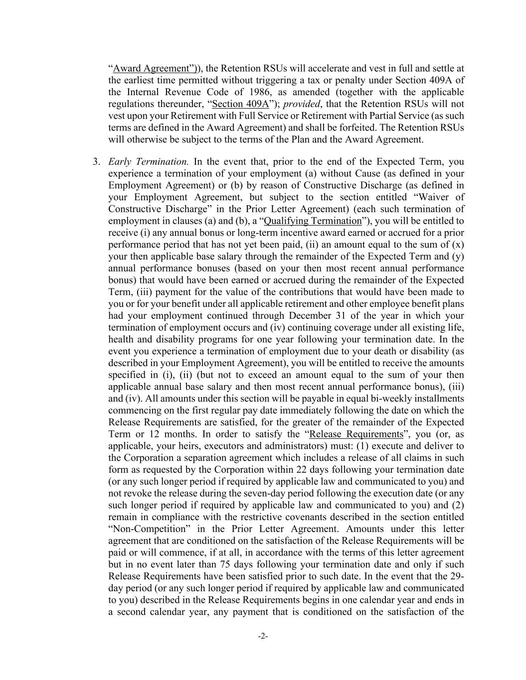
-2- “Award Agreement”)), the Retention RSUs will accelerate and vest in full and settle at the earliest time permitted without triggering a tax or penalty under Section 409A of the Internal Revenue Code of 1986, as amended (together with the applicable regulations thereunder, “Section 409A”); provided, that the Retention RSUs will not vest upon your Retirement with Full Service or Retirement with Partial Service (as such terms are defined in the Award Agreement) and shall be forfeited. The Retention RSUs will otherwise be subject to the terms of the Plan and the Award Agreement. 3. Early Termination. In the event that, prior to the end of the Expected Term, you experience a termination of your employment (a) without Cause (as defined in your Employment Agreement) or (b) by reason of Constructive Discharge (as defined in your Employment Agreement, but subject to the section entitled “Waiver of Constructive Discharge” in the Prior Letter Agreement) (each such termination of employment in clauses (a) and (b), a “Qualifying Termination”), you will be entitled to receive (i) any annual bonus or long-term incentive award earned or accrued for a prior performance period that has not yet been paid, (ii) an amount equal to the sum of (x) your then applicable base salary through the remainder of the Expected Term and (y) annual performance bonuses (based on your then most recent annual performance bonus) that would have been earned or accrued during the remainder of the Expected Term, (iii) payment for the value of the contributions that would have been made to you or for your benefit under all applicable retirement and other employee benefit plans had your employment continued through December 31 of the year in which your termination of employment occurs and (iv) continuing coverage under all existing life, health and disability programs for one year following your termination date. In the event you experience a termination of employment due to your death or disability (as described in your Employment Agreement), you will be entitled to receive the amounts specified in (i), (ii) (but not to exceed an amount equal to the sum of your then applicable annual base salary and then most recent annual performance bonus), (iii) and (iv). All amounts under this section will be payable in equal bi-weekly installments commencing on the first regular pay date immediately following the date on which the Release Requirements are satisfied, for the greater of the remainder of the Expected Term or 12 months. In order to satisfy the “Release Requirements”, you (or, as applicable, your heirs, executors and administrators) must: (1) execute and deliver to the Corporation a separation agreement which includes a release of all claims in such form as requested by the Corporation within 22 days following your termination date (or any such longer period if required by applicable law and communicated to you) and not revoke the release during the seven-day period following the execution date (or any such longer period if required by applicable law and communicated to you) and (2) remain in compliance with the restrictive covenants described in the section entitled “Non-Competition” in the Prior Letter Agreement. Amounts under this letter agreement that are conditioned on the satisfaction of the Release Requirements will be paid or will commence, if at all, in accordance with the terms of this letter agreement but in no event later than 75 days following your termination date and only if such Release Requirements have been satisfied prior to such date. In the event that the 29- day period (or any such longer period if required by applicable law and communicated to you) described in the Release Requirements begins in one calendar year and ends in a second calendar year, any payment that is conditioned on the satisfaction of the

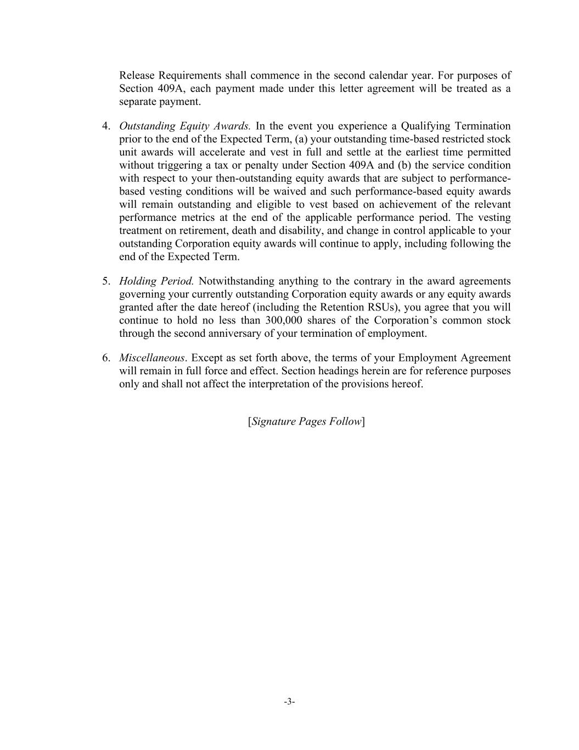
-3- Release Requirements shall commence in the second calendar year. For purposes of Section 409A, each payment made under this letter agreement will be treated as a separate payment. 4. Outstanding Equity Awards. In the event you experience a Qualifying Termination prior to the end of the Expected Term, (a) your outstanding time-based restricted stock unit awards will accelerate and vest in full and settle at the earliest time permitted without triggering a tax or penalty under Section 409A and (b) the service condition with respect to your then-outstanding equity awards that are subject to performance- based vesting conditions will be waived and such performance-based equity awards will remain outstanding and eligible to vest based on achievement of the relevant performance metrics at the end of the applicable performance period. The vesting treatment on retirement, death and disability, and change in control applicable to your outstanding Corporation equity awards will continue to apply, including following the end of the Expected Term. 5. Holding Period. Notwithstanding anything to the contrary in the award agreements governing your currently outstanding Corporation equity awards or any equity awards granted after the date hereof (including the Retention RSUs), you agree that you will continue to hold no less than 300,000 shares of the Corporation’s common stock through the second anniversary of your termination of employment. 6. Miscellaneous. Except as set forth above, the terms of your Employment Agreement will remain in full force and effect. Section headings herein are for reference purposes only and shall not affect the interpretation of the provisions hereof. [Signature Pages Follow]

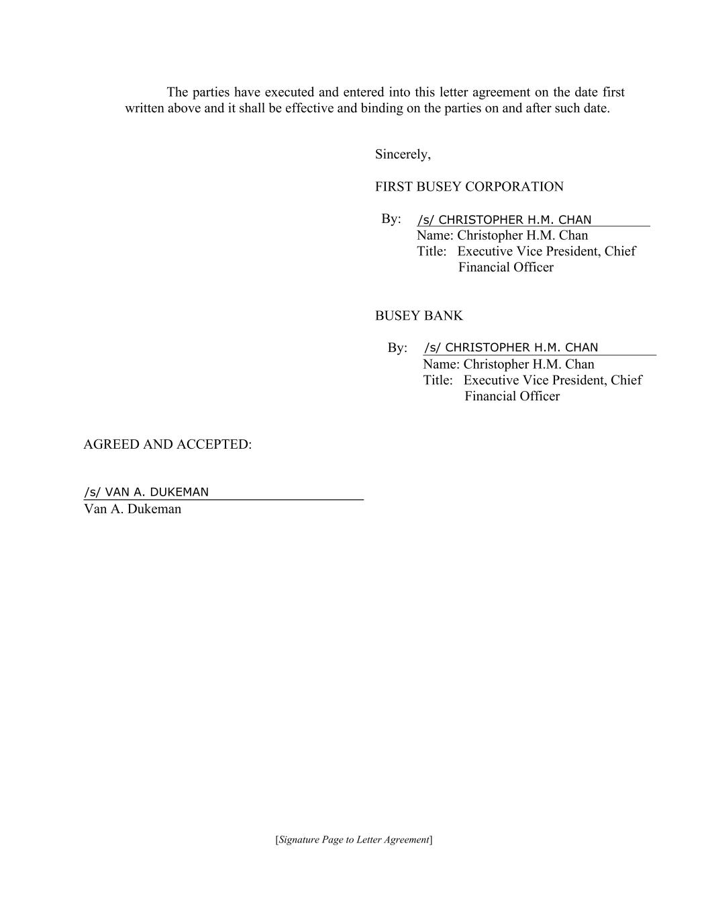
[Signature Page to Letter Agreement] The parties have executed and entered into this letter agreement on the date first written above and it shall be effective and binding on the parties on and after such date. Sincerely, FIRST BUSEY CORPORATION By: Name: Christopher H.M. Chan Title: Executive Vice President, Chief Financial Officer BUSEY BANK By: Name: Christopher H.M. Chan Title: Executive Vice President, Chief Financial Officer AGREED AND ACCEPTED: Van A. Dukeman

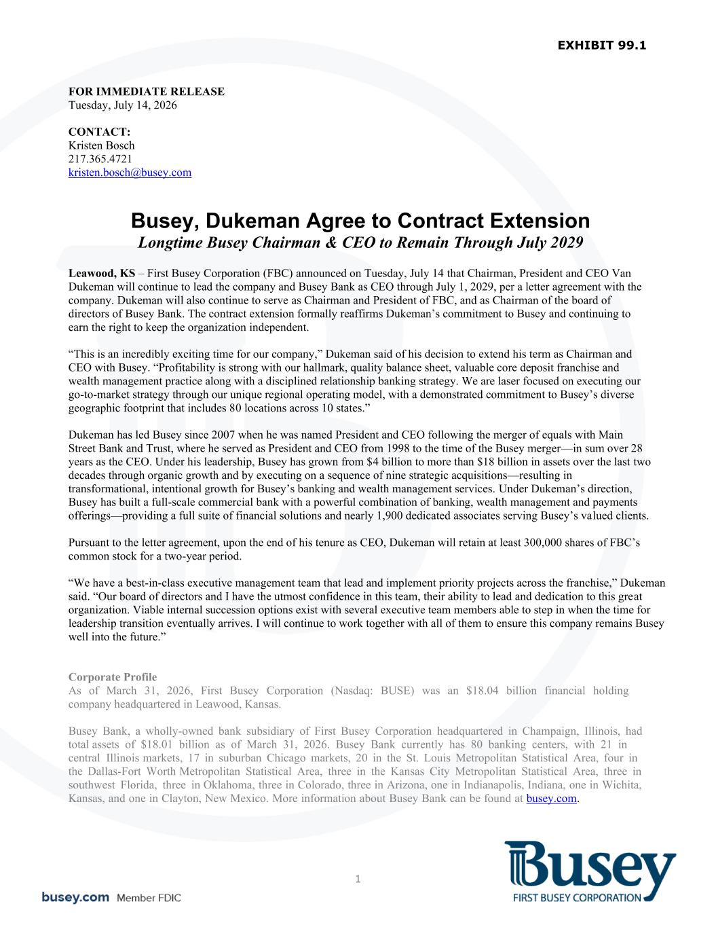
1 FOR IMMEDIATE RELEASE Tuesday, July 14, 2026 CONTACT: Kristen Bosch 217.365.4721 kristen.bosch@busey.com Busey, Dukeman Agree to Contract Extension Longtime Busey Chairman & CEO to Remain Through July 2029 Leawood, KS – First Busey Corporation (FBC) announced on Tuesday, July 14 that Chairman, President and CEO Van Dukeman will continue to lead the company and Busey Bank as CEO through July 1, 2029, per a letter agreement with the company. Dukeman will also continue to serve as Chairman and President of FBC, and as Chairman of the board of directors of Busey Bank. The contract extension formally reaffirms Dukeman’s commitment to Busey and continuing to earn the right to keep the organization independent. “This is an incredibly exciting time for our company,” Dukeman said of his decision to extend his term as Chairman and CEO with Busey. “Profitability is strong with our hallmark, quality balance sheet, valuable core deposit franchise and wealth management practice along with a disciplined relationship banking strategy. We are laser focused on executing our go-to-market strategy through our unique regional operating model, with a demonstrated commitment to Busey’s diverse geographic footprint that includes 80 locations across 10 states.” Dukeman has led Busey since 2007 when he was named President and CEO following the merger of equals with Main Street Bank and Trust, where he served as President and CEO from 1998 to the time of the Busey merger—in sum over 28 years as the CEO. Under his leadership, Busey has grown from $4 billion to more than $18 billion in assets over the last two decades through organic growth and by executing on a sequence of nine strategic acquisitions—resulting in transformational, intentional growth for Busey’s banking and wealth management services. Under Dukeman’s direction, Busey has built a full-scale commercial bank with a powerful combination of banking, wealth management and payments offerings—providing a full suite of financial solutions and nearly 1,900 dedicated associates serving Busey’s valued clients. Pursuant to the letter agreement, upon the end of his tenure as CEO, Dukeman will retain at least 300,000 shares of FBC’s common stock for a two-year period. “We have a best-in-class executive management team that lead and implement priority projects across the franchise,” Dukeman said. “Our board of directors and I have the utmost confidence in this team, their ability to lead and dedication to this great organization. Viable internal succession options exist with several executive team members able to step in when the time for leadership transition eventually arrives. I will continue to work together with all of them to ensure this company remains Busey well into the future.” Corporate Profile As of March 31, 2026, First Busey Corporation (Nasdaq: BUSE) was an $18.04 billion financial holding company headquartered in Leawood, Kansas. Busey Bank, a wholly-owned bank subsidiary of First Busey Corporation headquartered in Champaign, Illinois, had total assets of $18.01 billion as of March 31, 2026. Busey Bank currently has 80 banking centers, with 21 in central Illinois markets, 17 in suburban Chicago markets, 20 in the St. Louis Metropolitan Statistical Area, four in the Dallas-Fort Worth Metropolitan Statistical Area, three in the Kansas City Metropolitan Statistical Area, three in southwest Florida, three in Oklahoma, three in Colorado, three in Arizona, one in Indianapolis, Indiana, one in Wichita, Kansas, and one in Clayton, New Mexico. More information about Busey Bank can be found at busey.com.

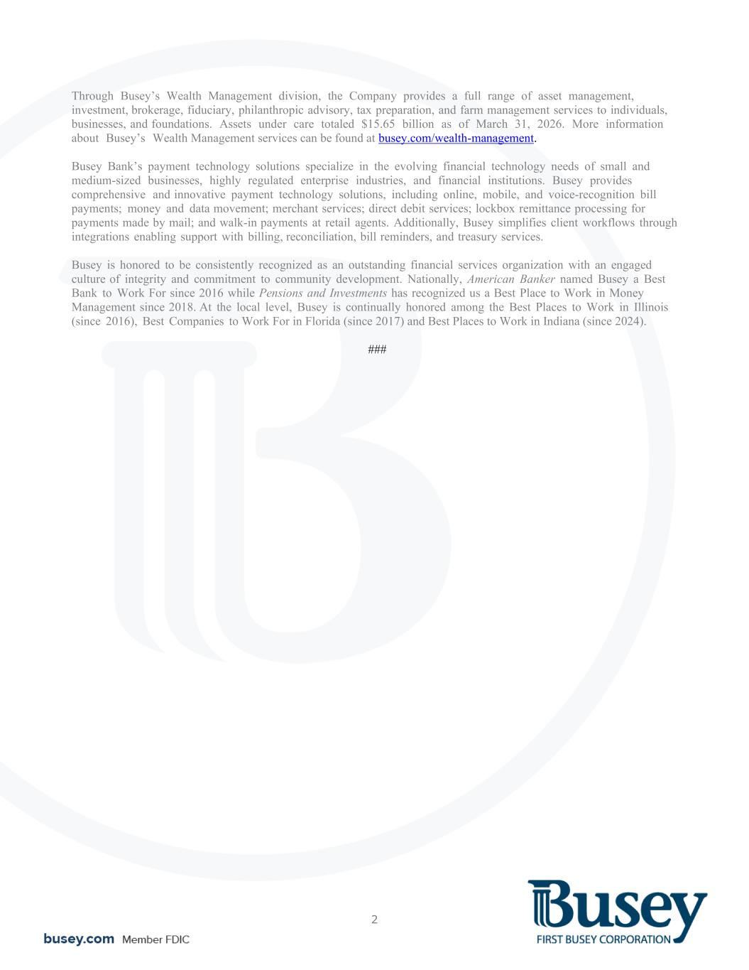
2 Through Busey’s Wealth Management division, the Company provides a full range of asset management, investment, brokerage, fiduciary, philanthropic advisory, tax preparation, and farm management services to individuals, businesses, and foundations. Assets under care totaled $15.65 billion as of March 31, 2026. More information about Busey’s Wealth Management services can be found at busey.com/wealth-management. Busey Bank’s payment technology solutions specialize in the evolving financial technology needs of small and medium-sized businesses, highly regulated enterprise industries, and financial institutions. Busey provides comprehensive and innovative payment technology solutions, including online, mobile, and voice-recognition bill payments; money and data movement; merchant services; direct debit services; lockbox remittance processing for payments made by mail; and walk-in payments at retail agents. Additionally, Busey simplifies client workflows through integrations enabling support with billing, reconciliation, bill reminders, and treasury services. Busey is honored to be consistently recognized as an outstanding financial services organization with an engaged culture of integrity and commitment to community development. Nationally, American Banker named Busey a Best Bank to Work For since 2016 while Pensions and Investments has recognized us a Best Place to Work in Money Management since 2018. At the local level, Busey is continually honored among the Best Places to Work in Illinois (since 2016), Best Companies to Work For in Florida (since 2017) and Best Places to Work in Indiana (since 2024). ###

